**Cisco Packet Tracer**

**ABC COMPANY**

Done by : S Alankritha

Reg No : 2347146

Team Mate:

Done by : Pratham M

Reg No : 2347139

**ABC Company Network Design and Implementation Overview:**

We have meticulously crafted a network infrastructure tailored to meet the specific requirements outlined below for a small-scale setup for ABC Company. The network design ensures that each branch operates autonomously while maintaining a high level of security.

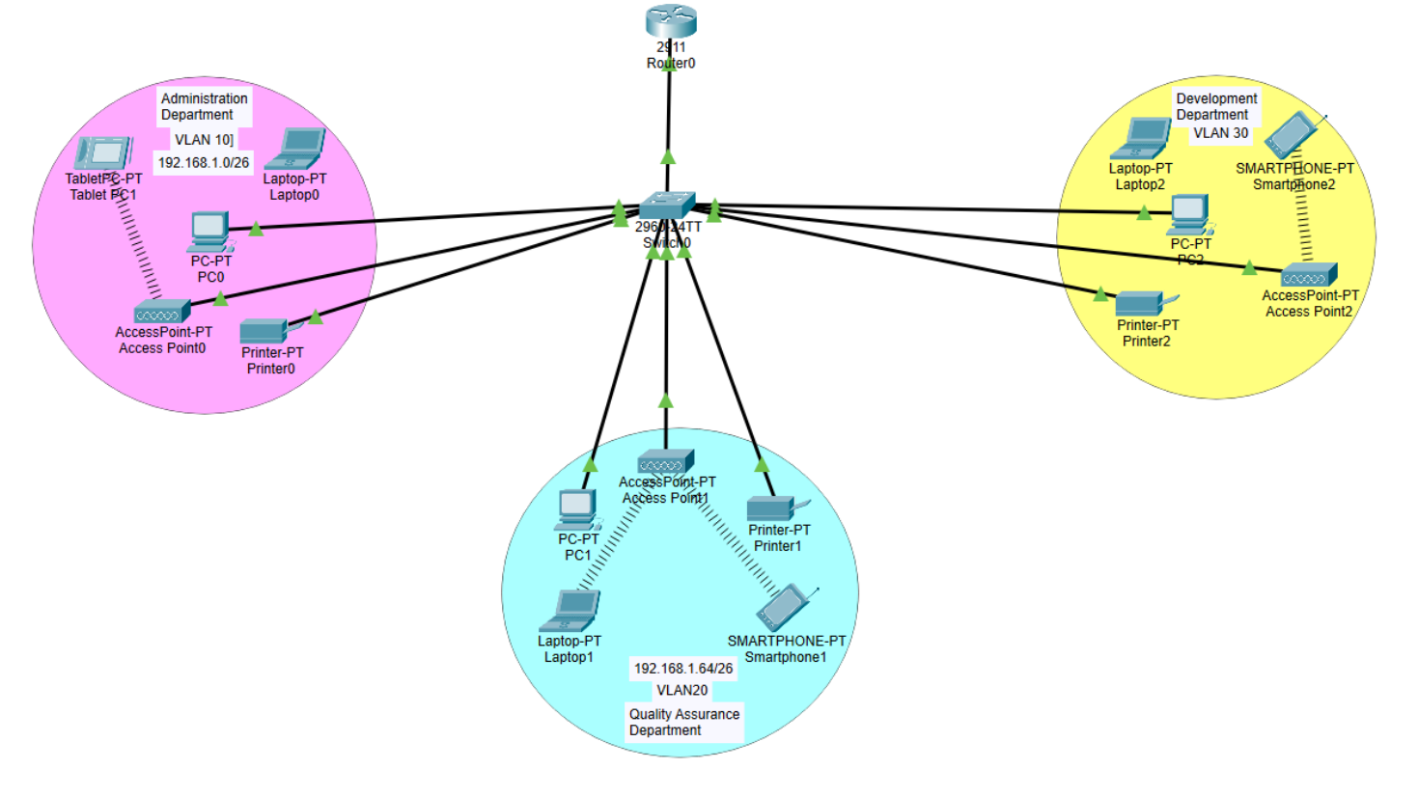

**Requirements Considered:**

- The ABC Company comprises three distinct departments: Administration, Quality, and Development.

- Three separate VLANs are designated to correspond with each department, ensuring isolated network environments.

- Each department will be equipped with an Access Point for wireless network accessibility.

- Automatic IPv4 address assignment is facilitated through DHCP server configuration on the router.

- Interdepartmental communication is regulated via inter-VLAN routing to maintain segregation while enabling necessary connectivity between devices such as smartphones, tablets, laptops, PCs, and printers.

**Implementation Details:**

1. Cisco Products Utilized:

- 1 Router

- 1 Switch (suitable for a small-scale company)

2. Departmental Structure:

- Administration Department

- Quality Department

- Development Department

3. VLAN Configuration:

- Three VLANs configured to match each department for network segmentation.

4. Wireless Network Setup:

- Each department is equipped with an Access Point to facilitate wireless connectivity.

5. Automatic IP Address Assignment:

- IPv4 addresses are obtained automatically through DHCP server configuration on the router.

6. Inter-VLAN Routing:

- Implemented to enable communication between devices across different VLANs while maintaining isolation.

**Simulation and OSI Model Specifications:**

* File Transfer:
  + OSI Model Specifications:
    - Application Layer: File transfer protocol (FTP)
    - Transport Layer: Transmission Control Protocol (TCP)
    - Network Layer: Internet Protocol (IP)
    - Data Link Layer: Ethernet
    - Physical Layer: Copper cabling
* Web Application Hosting/Accessing:
  + OSI Model Specifications:
    - Application Layer: Hypertext Transfer Protocol (HTTP)
    - Transport Layer: Transmission Control Protocol (TCP)
    - Network Layer: Internet Protocol (IP)
    - Data Link Layer: Ethernet
    - Physical Layer: Copper cabling

**Assigning IP Address**

**IP Address Allocation:**

- Base Network: 192.168.1.0

- Number of Subnets: 3

- Subnet Mask: 255.255.255.192

- Block Size: 64

**IP Allocation for Each Department:**

1. *Administration Department:*

- Network ID: 192.168.1.0

- Broadcast ID: 192.168.1.63

- Host Range: 192.168.1.1 - 192.168.1.62

*2. Quality Department:*

- Network ID: 192.168.1.64

- Broadcast ID: 192.168.1.127

- Host Range: 192.168.1.65 - 192.168.1.126

*3. Development Department:*

- Network ID: 192.168.1.128

- Broadcast ID: 192.168.1.191

- Host Range: 192.168.1.129 - 192.168.1.190

Outputs:

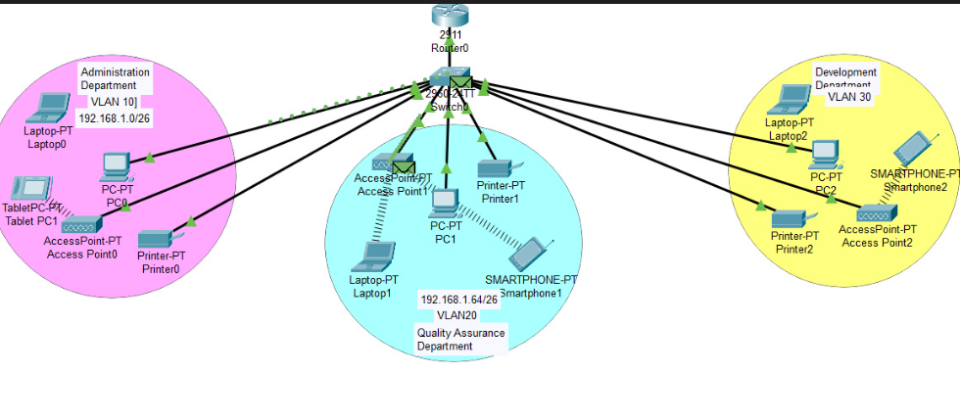

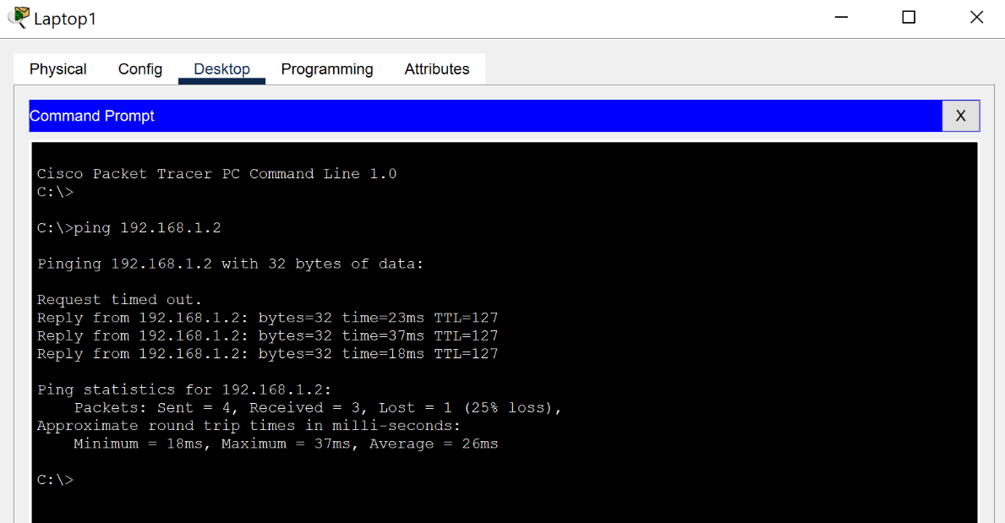

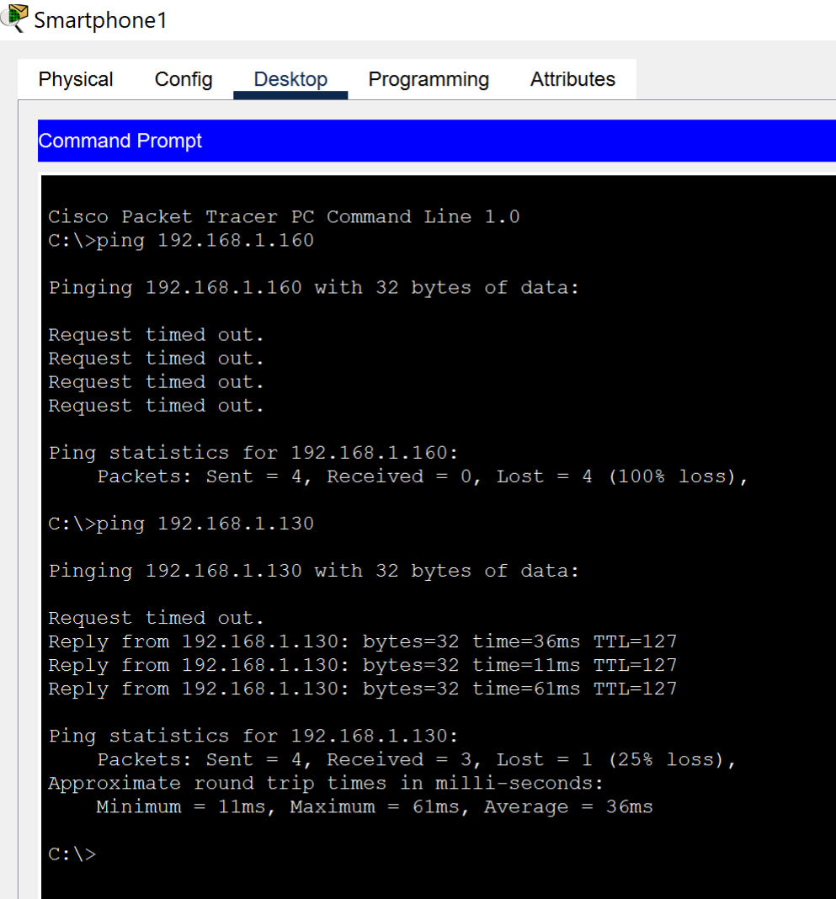

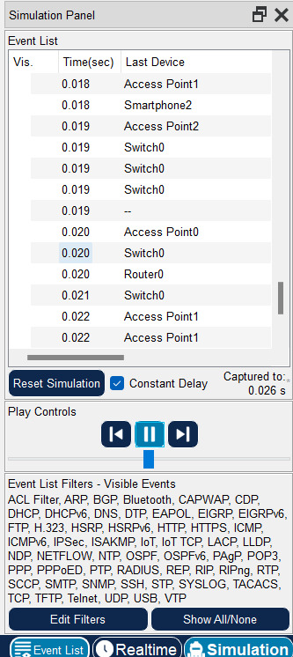

**The Below is kind of prototype for the company**

1. 1 2911 router

2. 3 pc and printer for three department

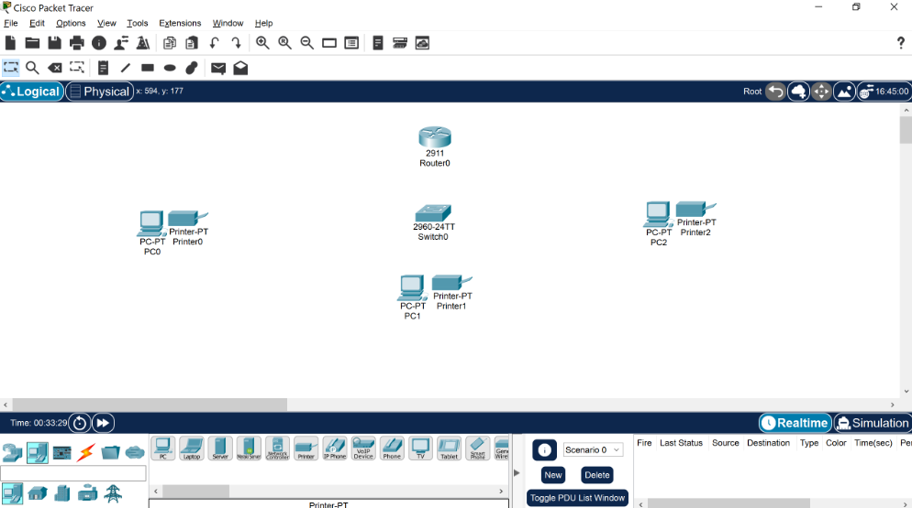

**Configuring the password and ssid for the wifi name [access point]**

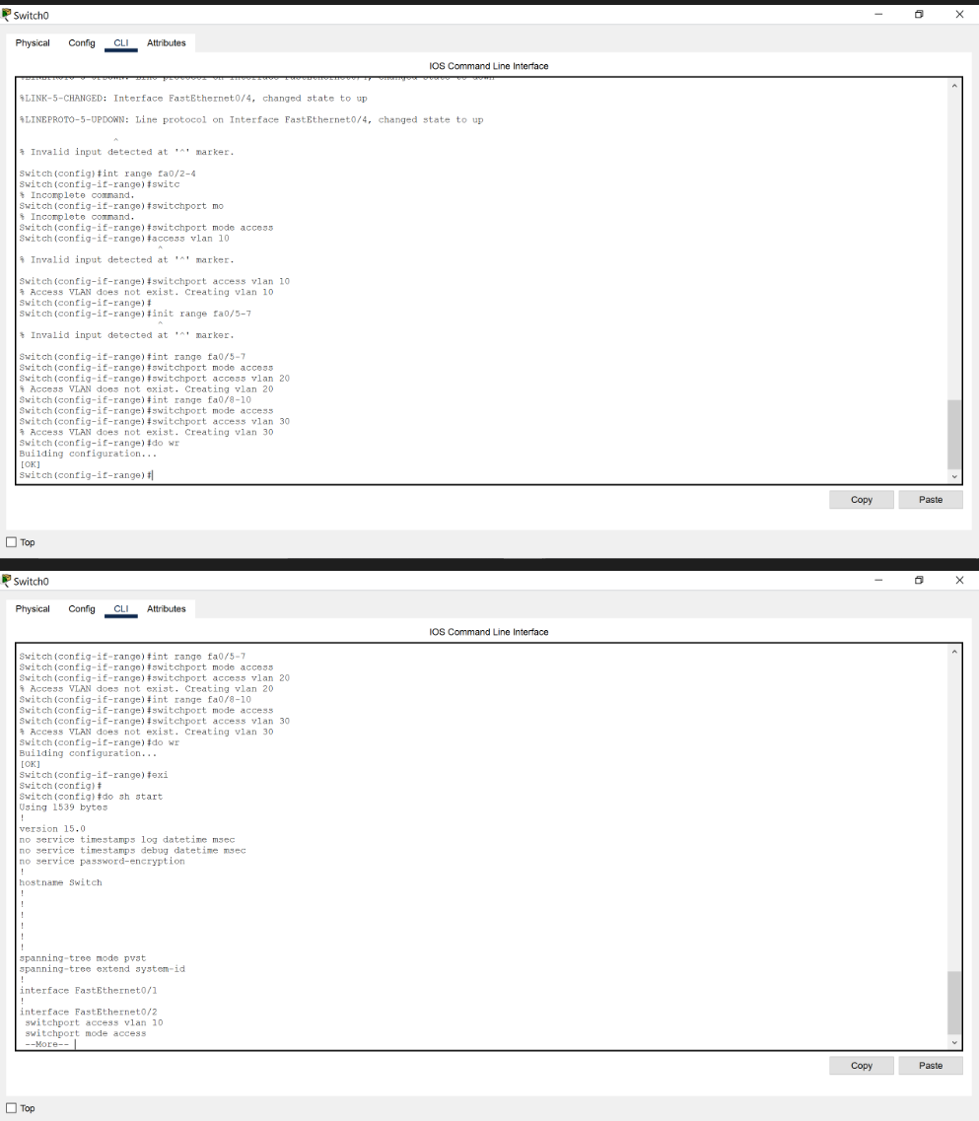

**Configuring the Router**

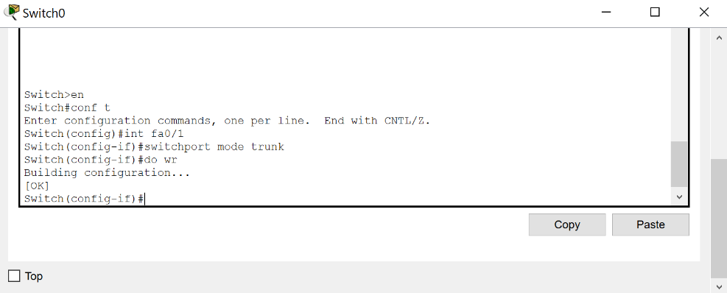

**Configuring the router gig:**

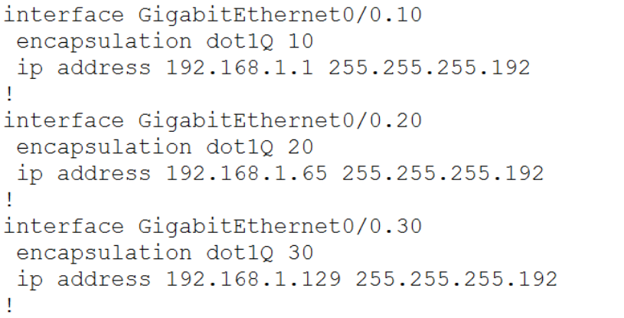

**Connecting the devices with the available wireless networks:**

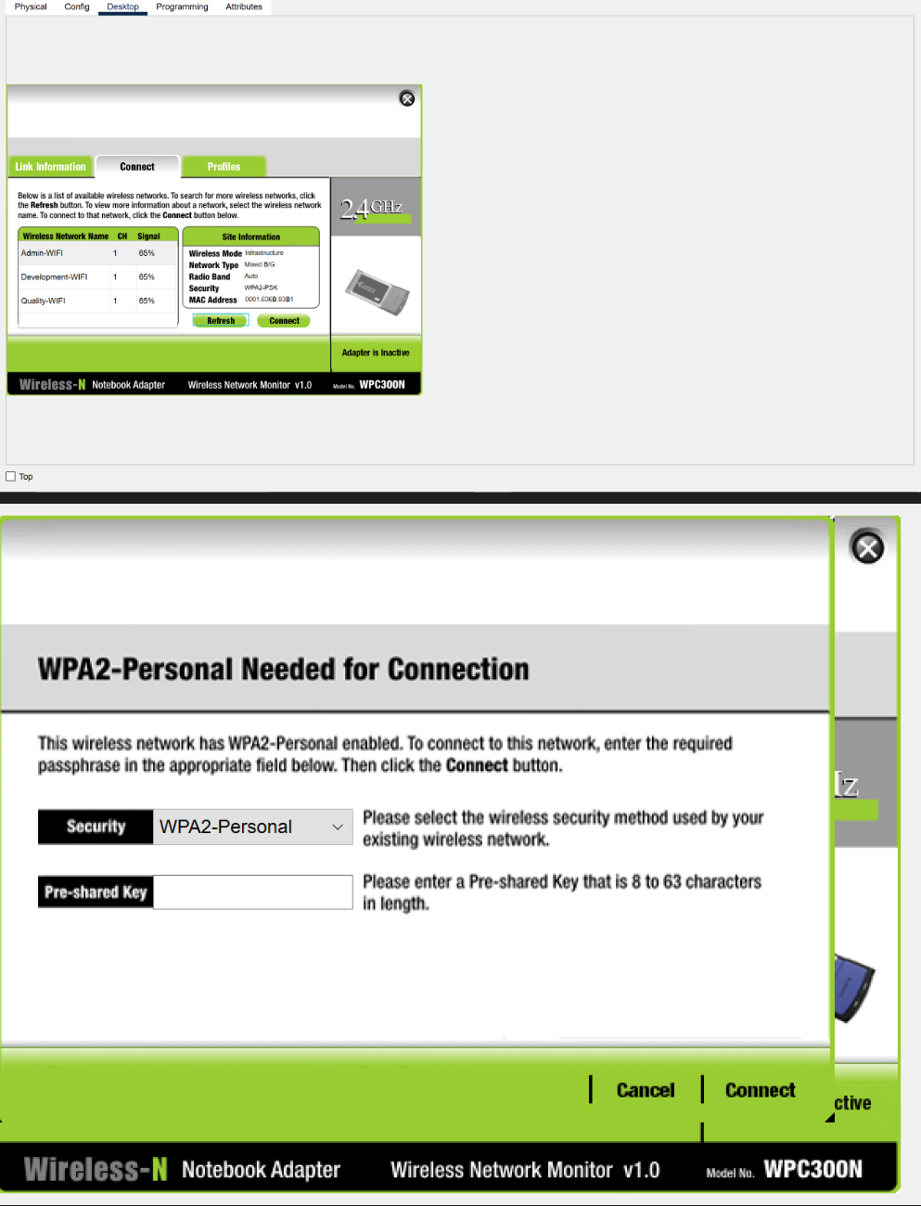

**Conclusion:**

With the implementation of this network design, ABC Company ensures not only the seamless operation of its departments but also prioritizes security and efficiency in its network infrastructure. Each department can function independently while maintaining necessary connectivity, contributing to enhanced productivity and streamlined operations within the organization.